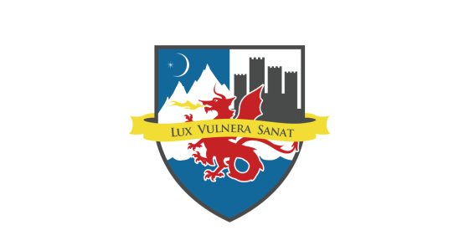
World Life Institute
Center of Excellence
Global Nuclear Awareness Program

VOLUNTEER APPLICATION

Our organization encourages the participation of volunteers who support our mission. If you agree with our mission and are willing to be interviewed and trained in our procedures, we encourage you to complete this application.

The information on this form will be kept confidential and will help us find the most satisfying and appropriate volunteer opportunity for you.

Thank you for your interest in our organization.

Name: Address: City: State: Zip: Phone: Email: Employer/School: Position:
Any special talents or skills you have that you feel would benefit our organization?

Interests: Please tell us in which areas you are interested in volunteering
Administration
Events
Program
Fundraising
Communication
____ Marketing

Please indicate days available: Mon Tues Wed Thurs Fri Sat Sun
Times available: From to
Any physical limitations?

In case of emergency contact:

As a volunteer of our organization I agree to abide by the policies and procedures. I understand that I will be volunteering at my own risk and that the organization, its employees and affiliates, cannot assume any responsibility for any liability for any accident, injury or health problem which may arise from any volunteer work I perform for the organization. I agree that all the work I do is on a volunteer basis and I am not eligible to receive any monetary payment or reward.

Signature: Date:

